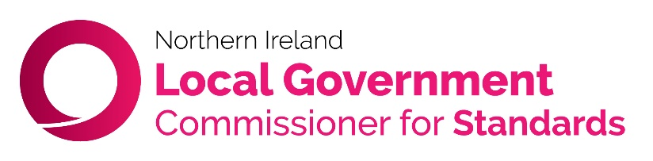
15 June 2023
PRESS RELEASE
Alderman suspended from Planning Committee for three months
Alderman John Smyth (Antrim and Newtownabbey Borough Council) has been suspended from sitting on the council’s Planning Committee for three months following an Adjudication Hearing held today (15 June).
The suspension was imposed after an investigation was carried out into a complaint that Alderman Smyth had breached the Local Government Code of Conduct for Councillors.
In March 2019 the Alderman sat on the council’s Planning Committee when his employer, Mr Trevor Clarke MLA, made representations to the Committee on three planning applications. In one application, Mr Clarke was the Agent for the application via his firm Versatile Planning Consultancy.
During the meeting Alderman Smyth did not make a declaration of interest in respect of any matter and did not leave the meeting.
Although all of the planning applications were refused, the investigation looked at the Alderman’s actions in line with paragraph 6.3 of the Code which requires a councillor to declare any significant private or personal non-pecuniary interest in a matter arising at a council or committee meeting.
Paragraph 6.4 also states that in these cases it is the personal responsibility of a councillor to withdraw from the meeting.
At the Hearing, Assistant Commissioner Ian Gordon concluded that as his presence gave rise to a potential conflict of interest. the Alderman should have erred on the side of caution by removing himself from the meeting,
Although he noted his previous record of good service and compliance with the code, and that his actions had no detrimental effect on the outcome of the planning applications, the Assistant Commissioner noted that the Alderman is an experienced councillor with approximately 20 years of service. He should therefore have been aware of how his actions would be viewed, referencing the Commissioner’s Guidance to the Code of Conduct, which states:
“The key consideration is therefore not whether your decision would be influenced by your interest but whether a member of the public – if he or she knew all of the relevant facts – would perceive that the interest is such that it would be likely to influence your decision”.
He decided that a partial suspension from the council’s Planning Committee, for the period from Monday 17 July 2023 to Sunday 15 October 2023 inclusive, was an appropriate and proportionate reflection of the seriousness of the breaches.
Notes:
The Alderman may appeal to the High Court against this decision in accordance with the provisions of the Local Government Act (Northern Ireland) 2014.
The Assistant Commissioner’s full written decision will be made available shortly on the Commissioner’s website at:
https://nipso.org.uk/nilgcs/hearings-and-adjudication-decisions/

ENDS
For further information contact Andrew Ruston on 07503640551 or communications@nipso.org.uk

